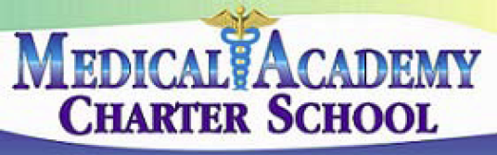 No. 102
SECTION: PROGRAMS

TITLE: ACADEMIC STANDARDS
MEDICAL ACADEMY ADOPTED: 4/8/14
CHARTER SCHOOL REVISED:

102. ACADEMIC STANDARDS

The Board recognizes that education is a vital function of the state and community. The school community, through the strategic planning process, shall be encouraged to participate in the development of the educational goals and academic standards established for this school.

Academic standards shall be defined as what a student should know and be able to do at a specified grade level; they shall describe the knowledge and skills students will be expected to demonstrate in order to graduate.

The Board shall establish academic standards for students to attain, in accordance with those adopted by the State Board of Education, in the following content areas:

1. Reading, Writing, Speaking and Listening.
2. Mathematics.
3. Science and Technology.
4. Environment and Ecology.
5. Social Studies - to include history, geography, civics and government, and economics.
6. Arts and Humanities.
7. Career Education and Work.
8. Health, Safety and Physical Education.
9. Family and Consumer Science.
10. World Languages.

References:

State Board of Education Regulations – 22 PA Code Sec. 4.3, 4.4, 4.11, 4.12, 4.13

