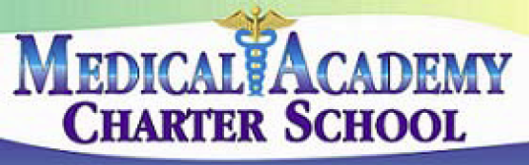 No. 108
SECTION: PROGRAMS

TITLE: ADOPTION OF TEXTBOOKS
MEDICAL ACADEMY ADOPTED: 4/8/14
CHARTER SCHOOL REVISED:

108. ADOPTION OF TEXTBOOKS

It is the responsibility of the Board to adopt all textbooks used for instruction in the educational program of this school.

For purposes of this policy, textbooks shall be defined as books purchased in classroom quantity or more and issued to each student in the class.

The Principal/CEO shall be responsible for the selection and recommendation of textbooks for Board consideration. No adoption or change of textbooks shall be made without the Principal/CEO's recommendation, except by a two-thirds vote of the Board.

The Principal/CEO or designee shall develop administrative regulations for the selection of textbooks.

Guidelines for selecting textbooks may include the following:

1. Professional staff members selected by the Principal/CEO or designee shall participate in the
selection process.
2. The staff shall continually research new sources of textbooks.
3. Textbooks currently in use shall be periodically evaluated for their continuing usefulness and
relevance.

In considering the approval of any proposed textbook, the Board will evaluate its:

1. Suitability for the maturity level and educational needs of the students who will be using the
book.
2. Freedom from bias.
3. Relationship to the curriculum.
4. Relationship to a continuous multi-grade program.
5. Impact on community standards of taste.
6. Manner of selection.
7. Cost.
8. Appearance and durability.

108. ADOPTION OF TEXTBOOKS- pg. 2

A list of all approved textbooks shall be prepared and maintained. It shall be reviewed periodically by the administration and made available for the information of the professional staff, Board members, students, parents/guardians and community.

References:

School Code – 24 P.S. Sec. 508, 801, 803

